**titaARM Project**

**1. Project Purpose**

When choosing a project, we considered the utility provided in practice and compliance with the laboratory content.

There is a great loss of material and blood in ship accidents. Also, ship accidents are causing serious environmental pollution. We want to prevent ship accidents so there will be less loss.

**2. Materials**

* Arduino UNO R3
* Ultrasonic Sensor (HC-SR04)
* DC Motor (1 piece or 2 pieces)
* L293D Integrated
* Buzzer
* 2 x LED (Green – Red)
* Switch
* Resistors for LED and Buzzer

**3. How We Did**

Firstly, we dediced to control every components seperate from each other. We only control a motor, after we only control ultrasonic sensor etc. Then, we wanted to combine all controller circuit in a circuit so we needed to develop a good algorithm. We combined the circuits step by step. For example, we set led or dc motor by the value which we got from ultrasonic sensor. Then, we combined all controller and components in a circuit. Finally, we solved problems in the algorithm. Also, we developed the algorithm.

We had to measure the distance between the device and a obstacle for setting other components. So, we used ultrasonic sensor for measuring distance. Actually, we wanted to check under water but we couldn’t have a waterproof sensor. Generally, sensors which using for measuring distance are have same method. This method is include trigger and echo function. Sensors generate a small signal and wait, if the signal crosses a obstacle, return to sensor and we know the duration between generate of signal and return of signal. Finally, we calculate distance with using speed of voice.

After that, we checked the distance and set components value according to the length of distance. We worked with 4 intervals. We set these intervals according to the level of danger. Also, users can set first interval danger level but other intervals is calculated automatic in algorithm, each range is 50 cm length excluding the first interval.

* 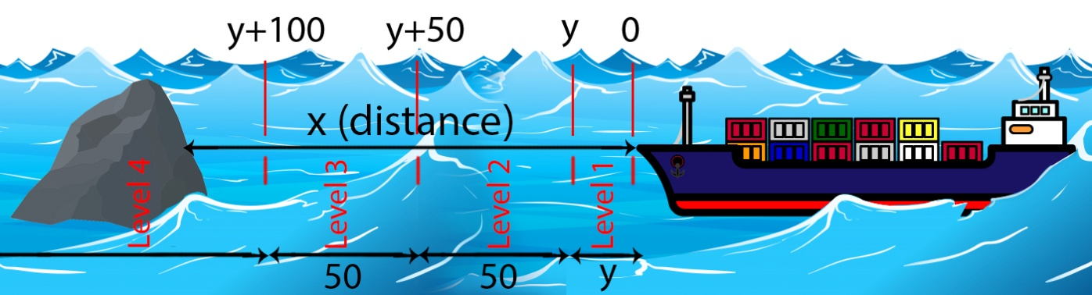When value of “x” in Level 4 (x>y+100),

Diagram 1: How the Project Works. y= Danger level which is set by captain. x= Distance between ship and obstacle.

it’s ok! There isn't any dangers. Green led is on and the direction of motors is normal.

* When value of “x” in Level 3 (y+100>x>y+50),

There is a danger in away. Green led is on / off state in loop. Motors are normal.

* When value of “x” in Level 2 (y+50 >x>y),

There is a danger in near. Red led and buzzer is on / off state in loop, and loop time based on distance between ship and obstacle. Motors stop.

* When value of “x” in Level 1 (x<y),

There is a danger in very close range. Red is on and motors rotate reverse direction.

**4. Circuit Diagram**

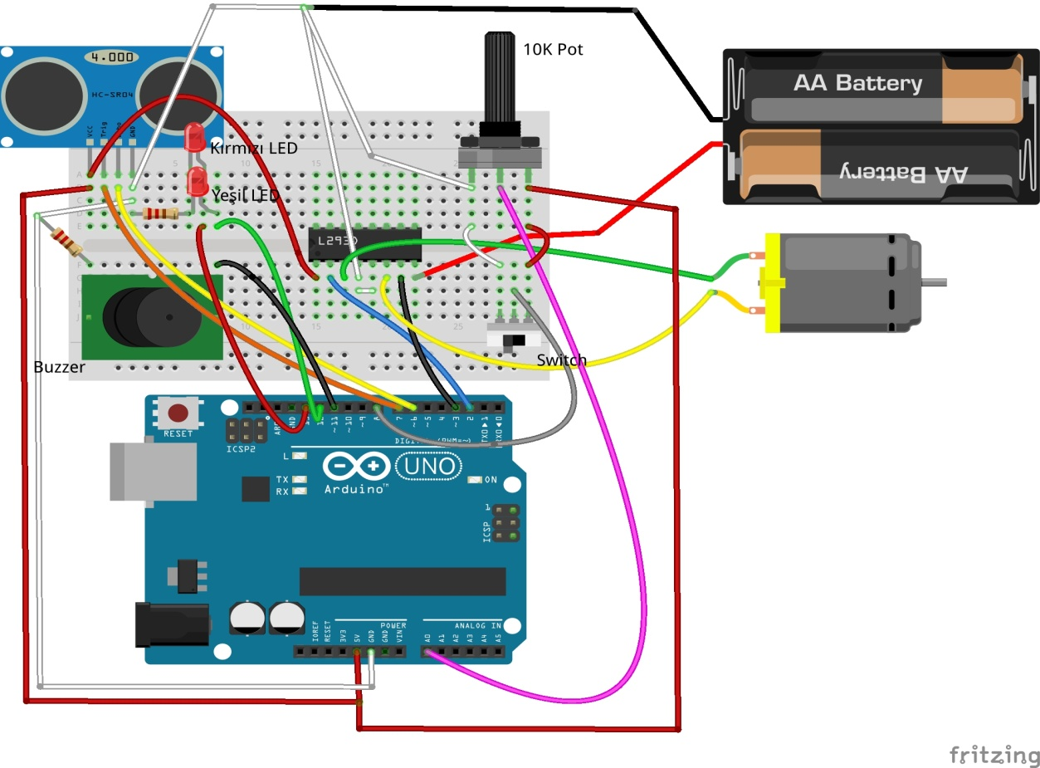

**5. Algorithm**

Our code consist of 6 ino files.

1. anaKomut.ino

|  |  |  |  |  |  |  |  |  |  |  |  |  |  |  |  |  |  |  |  |  |  |  |  |  |  |  |  |  |  |  |  |  |  |  |  |  |  |  |  |  |  |  |  |  |  |  |  |  |  |  |  |  |  |  |  |  |  |  |  |  |  |  |  |  |  |  |  |  |  |  |  |  |  |  |  |  |  |  |  |  |  |  |  |  |  |  |  |  |  |  |  |  |  |  |  |  |  |  |  |  |  |  |  |  |  |  |  |  |  |  |  |  |  |  |  |  |  |  |  |  |  |  |  |  |  |  |  |  |  |  |  |  |  |  |  |  |  |  |  |  |  |  |  |  |  |  |  |  |  |  |  |  |  |  |  |  |  |  |  |  |  |  |  |  |  |  |  |  |  |  |  |  |  |  |  |  |  |  |  |  |  |  |  |  |  |  |  |  |  |  |  |  |  |  |  |  |  |  |  |  |  |  |  |  |  |  |  |  |  |  |  |  |  |  |  |  |  |  |  |  |  |  |  |  |  |  |  |  |  |  |
| --- | --- | --- | --- | --- | --- | --- | --- | --- | --- | --- | --- | --- | --- | --- | --- | --- | --- | --- | --- | --- | --- | --- | --- | --- | --- | --- | --- | --- | --- | --- | --- | --- | --- | --- | --- | --- | --- | --- | --- | --- | --- | --- | --- | --- | --- | --- | --- | --- | --- | --- | --- | --- | --- | --- | --- | --- | --- | --- | --- | --- | --- | --- | --- | --- | --- | --- | --- | --- | --- | --- | --- | --- | --- | --- | --- | --- | --- | --- | --- | --- | --- | --- | --- | --- | --- | --- | --- | --- | --- | --- | --- | --- | --- | --- | --- | --- | --- | --- | --- | --- | --- | --- | --- | --- | --- | --- | --- | --- | --- | --- | --- | --- | --- | --- | --- | --- | --- | --- | --- | --- | --- | --- | --- | --- | --- | --- | --- | --- | --- | --- | --- | --- | --- | --- | --- | --- | --- | --- | --- | --- | --- | --- | --- | --- | --- | --- | --- | --- | --- | --- | --- | --- | --- | --- | --- | --- | --- | --- | --- | --- | --- | --- | --- | --- | --- | --- | --- | --- | --- | --- | --- | --- | --- | --- | --- | --- | --- | --- | --- | --- | --- | --- | --- | --- | --- | --- | --- | --- | --- | --- | --- | --- | --- | --- | --- | --- | --- | --- | --- | --- | --- | --- | --- | --- | --- | --- | --- | --- | --- | --- | --- | --- | --- | --- | --- | --- | --- | --- | --- | --- | --- | --- | --- | --- | --- | --- | --- | --- | --- | --- |
| |  |  | | --- | --- | |  | int echoPin=6;  int trigPin=7; | |  | int yesilLed=12; | |  | int kirmiziLed=13; | |  | int MotorInput1=2; | |  | int MotorInput2=3; | |  | int sistemAcKapa=8; | |  | int ses=11; | |  | int pot=0; | |  |  | |  | int oncekiDurum; | |  | int simdikiDurum; | |  | int sayac=0; | |  | int sinirMesafesi; | |  |  | |  |  | |  | long mesafe; | |  |  | |  |  | |  |  | |  | /* | |  | Ana döngüden 2 döngüde bir gelen simdiki ve onceki durum değerlerini alıyoruz. | |  | İki durumu karşılaştırıp sonuca göre uyarı sistemini çalıştıracağız. | |  | */ | |  |  | |  | void kontrolEt(int simdiki,int onceki=3){ | |  | digitalWrite(yesilLed, LOW); | |  | digitalWrite(kirmiziLed, LOW); | |  |  | |  | if(onceki==simdiki){ | |  | uyari(simdiki,mesafe); | |  | }else{ | |  | if(simdiki<onceki){ | |  | uyari(simdiki,mesafe); | |  | }else{ | |  | uyari(onceki,mesafe); | |  | } | |  | } | |  | } | |  |  | |  | void setup() { | |  | // put your setup code here, to run once: | |  | Serial.begin (9600); | |  | pinMode(trigPin, OUTPUT); | |  | pinMode(echoPin, INPUT); | |  | pinMode(kirmiziLed, OUTPUT); | |  | pinMode(yesilLed, OUTPUT); | |  | pinMode(ses, OUTPUT); | |  | pinMode(MotorInput1, OUTPUT); | |  | pinMode(MotorInput2, OUTPUT); | |  | pinMode(sistemAcKapa, INPUT); | |  | Serial.println("Pinler ayarlandı."); | |  | } | |  |  | |  | void loop() { | |  |  | |  | if(sistemAcikMi()==true){ | |  | sinirMesafesi = analogRead(pot); | |  | Serial.print("Pot Değeri: "); | |  | Serial.print(sinirMesafesi); | |  | sinirMesafesi = map(sinirMesafesi,0,1023,5,50); | |  | Serial.print(" - Map Değeri: "); | |  | Serial.println(sinirMesafesi); | |  |  | |  | long sure; | |  | digitalWrite(trigPin, LOW); | |  | delayMicroseconds(2); | |  | digitalWrite(trigPin, HIGH); | |  | delayMicroseconds(10); | |  | digitalWrite(trigPin, LOW); | |  | sure = pulseIn(echoPin, HIGH); | |  | mesafe = (sure/2) / 29.1; | |  |  | |  | /* | |  | Mesafeye göre durumun aciliyetini belirliyoruz. | |  | */ | |  |  | |  | if(mesafe>sinirMesafesi+150 || mesafe <0){ | |  | simdikiDurum=3; | |  | }else if(mesafe<sinirMesafesi+150 && mesafe >sinirMesafesi+100){ | |  | simdikiDurum=2; | |  | }else if(mesafe<sinirMesafesi+50 && mesafe >sinirMesafesi){ | |  | simdikiDurum=1; | |  | }else if(mesafe<sinirMesafesi){ | |  | simdikiDurum=0; | |  | } | |  |  | |  | /* | |  | Her iki dönütte bir kontrol ediyoruz. Sensörümüzden gelebilecek olan hatalı veriyi kontrol | |  | etmek için yapıyoruz bunu. Gelen değer bir önceki değer ile aynı değilse stabile olana kadar | |  | bekleriz, ve bu süreçte de ikisi arasında tehlikeli olana göre işlem yaparız. Stabileyse doğrudan | |  | uyarı sistemi ne yapması gerekiyorsa onu yapmalı. | |  | */ | |  | sayac++; | |  | if(sayac%2==0){ | |  | kontrolEt(simdikiDurum,oncekiDurum); | |  | } | |  |  | |  | /* | |  | Şimdiki durum bir sonraki döngüde eski(önceki) durum olacak. | |  | */ | |  | delay(500); | |  | oncekiDurum = simdikiDurum; | |  |  | |  | }else{ | |  | digitalWrite(ses,LOW); | |  | digitalWrite(kirmiziLed, LOW); | |  | digitalWrite(yesilLed, LOW); | |  | digitalWrite(MotorInput1, LOW); | |  | digitalWrite(MotorInput2, LOW); | |  | delay(250); | |  | } | |  |  | |  |  | |  |  | |  | } | |

2. motorKontrol.ino

|  |  |  |  |  |  |  |  |  |  |  |  |  |  |  |  |  |  |  |  |  |  |  |  |  |  |  |  |
| --- | --- | --- | --- | --- | --- | --- | --- | --- | --- | --- | --- | --- | --- | --- | --- | --- | --- | --- | --- | --- | --- | --- | --- | --- | --- | --- | --- |
| |  | | --- | |  | |  | void motorKontrol(int uyariSeviyesi){  //Serial.println(uyariSeviyesi); | |  |  | |  | if(uyariSeviyesi==0){ | |  | digitalWrite(MotorInput1, LOW); | |  | digitalWrite(MotorInput2, HIGH); | |  | }else if(uyariSeviyesi==1){ | |  | digitalWrite(MotorInput1, LOW); | |  | digitalWrite(MotorInput2, LOW); | |  | }else{ | |  | digitalWrite(MotorInput1, HIGH); | |  | digitalWrite(MotorInput2, LOW); | |  | } | |  | } | |

3. sesTonu.ino

|  |  |  |  |  |  |  |  |  |  |  |  |  |  |
| --- | --- | --- | --- | --- | --- | --- | --- | --- | --- | --- | --- | --- | --- |
| |  | | --- | |  | |  |  | |  | void ton(int mesafe){  digitalWrite(ses,HIGH); | |  | delay(mesafe); | |  | digitalWrite(ses,LOW); | |  | delay(mesafe); | |  | } | |

4. sesUyariSistemi.ino

|  |  |  |  |  |  |  |  |  |  |  |  |  |  |  |  |  |  |  |  |  |  |  |  |
| --- | --- | --- | --- | --- | --- | --- | --- | --- | --- | --- | --- | --- | --- | --- | --- | --- | --- | --- | --- | --- | --- | --- | --- |
| |  | | --- | |  | |  | /*  Gelen değerlere göre sesli uyarı sistemi farklı dönütler verecek | |  | Bunun için ayrı bir fonksiyon açıyoruz. | |  | */ | |  | void sesUyariSistemi(int uyariSeviyesi, int mesafe){ | |  | if(mesafe <100 && mesafe >10){ | |  | ton(mesafe); | |  | }else if(mesafe <10){ | |  | digitalWrite(ses,HIGH); | |  | }else{ | |  | } | |  | } | |

5. sistemAcikMi.ino

|  |  |  |  |  |  |  |  |  |  |  |  |  |  |  |  |  |  |
| --- | --- | --- | --- | --- | --- | --- | --- | --- | --- | --- | --- | --- | --- | --- | --- | --- | --- |
| |  | | --- | |  | |  | boolean sistemAcikMi(){  if(digitalRead(sistemAcKapa)==HIGH){ | |  | Serial.println("Sistem aktif."); | |  | return true; | |  | }else{ | |  | Serial.println("Sistem devre disi."); | |  | return false; | |  | } | |  | } | |

6. uyari.ino

|  |  |  |  |  |  |  |  |  |  |  |  |  |  |  |  |  |  |  |  |  |  |  |  |  |  |  |  |  |  |  |  |  |  |  |  |  |  |  |  |  |  |  |  |  |  |  |  |  |  |  |  |  |  |  |  |  |  |  |  |  |  |  |  |  |  |  |  |  |  |  |  |  |  |  |  |  |  |  |  |  |  |  |  |  |  |  |  |  |  |  |  |  |  |  |  |  |  |  |  |  |  |  |  |  |  |  |  |  |  |  |  |  |  |  |  |  |  |  |  |  |  |  |  |  |  |  |  |  |  |  |  |  |  |  |  |  |  |  |  |  |  |  |  |  |  |  |  |  |  |  |  |
| --- | --- | --- | --- | --- | --- | --- | --- | --- | --- | --- | --- | --- | --- | --- | --- | --- | --- | --- | --- | --- | --- | --- | --- | --- | --- | --- | --- | --- | --- | --- | --- | --- | --- | --- | --- | --- | --- | --- | --- | --- | --- | --- | --- | --- | --- | --- | --- | --- | --- | --- | --- | --- | --- | --- | --- | --- | --- | --- | --- | --- | --- | --- | --- | --- | --- | --- | --- | --- | --- | --- | --- | --- | --- | --- | --- | --- | --- | --- | --- | --- | --- | --- | --- | --- | --- | --- | --- | --- | --- | --- | --- | --- | --- | --- | --- | --- | --- | --- | --- | --- | --- | --- | --- | --- | --- | --- | --- | --- | --- | --- | --- | --- | --- | --- | --- | --- | --- | --- | --- | --- | --- | --- | --- | --- | --- | --- | --- | --- | --- | --- | --- | --- | --- | --- | --- | --- | --- | --- | --- | --- | --- | --- | --- | --- | --- | --- | --- | --- | --- | --- | --- |
| |  | | --- | |  | |  |  | |  | void uyari(int uyariSeviyesi, int mesafe){  int sure,donguSayisi,i; | |  | Serial.print("Sınır Mesafesi Deger Gelen = "); | |  | Serial.println(sinirMesafesi); | |  |  | |  | motorKontrol(uyariSeviyesi); | |  |  | |  | switch(uyariSeviyesi){ | |  |  | |  | case 0: | |  | Serial.print("Gemi engelden kaciyor, mesafe= "); | |  | Serial.println(mesafe); | |  | digitalWrite(kirmiziLed, HIGH); | |  | break; | |  |  | |  | case 1: | |  | Serial.print("Gemi tehlikede, motorlar durdu. Mesafe = "); | |  | Serial.println(mesafe); | |  | sure=map(mesafe,(sinirMesafesi),(sinirMesafesi+50),50,250); | |  | donguSayisi=500/(2*sure); | |  |  | |  |  | |  | if(donguSayisi!=0){ | |  | Serial.print(sure); | |  | Serial.print(" sns aralıklarla "); | |  | Serial.print(donguSayisi); | |  | Serial.println(" kere dönecek."); | |  |  | |  | for(i=0;i<=donguSayisi;i++){ | |  | Serial.print(i); | |  | Serial.println(". dongu."); | |  | digitalWrite(kirmiziLed, HIGH); | |  | digitalWrite(ses,HIGH); | |  | delay(sure); | |  | digitalWrite(kirmiziLed, LOW); | |  | digitalWrite(ses,LOW); | |  | delay(sure); | |  | } | |  | } | |  | break; | |  |  | |  | case 2: | |  | Serial.print(mesafe); | |  | Serial.println(" - 100 150 arası"); | |  | sure=map(mesafe,sinirMesafesi+50,sinirMesafesi+100,50,250); | |  | donguSayisi=500/(2*sure); | |  | Serial.print(sure); | |  | Serial.print(" sns aralıklarla "); | |  | Serial.print(donguSayisi); | |  | Serial.println(" kere dönecek."); | |  |  | |  | if(donguSayisi!=0){ | |  | for(i=0;i<=donguSayisi;i++){ | |  | Serial.print(i); | |  | Serial.println(". dongu."); | |  | digitalWrite(yesilLed, HIGH); | |  | delay(sure); | |  | digitalWrite(yesilLed, LOW); | |  | delay(sure); | |  | } | |  | } | |  |  | |  | break; | |  |  | |  | case 3: | |  | Serial.print(mesafe); | |  | Serial.println(" - Temiz"); | |  | digitalWrite(yesilLed, HIGH); | |  | break; | |  |  | |  | default: | |  | Serial.println("Default"); | |  | } | |  |  | |  | } | |